Predictive Analytics Using Historical Data
Forecasting Future Sales Trends — Stationery Sales Dataset
Task 3 · Due 22 Aug 2026 · Status: Completed

1. Objective
Build a predictive model on historical stationery sales data to forecast future revenue trends. The work covers data cleaning and preprocessing, model building using regression and time-series approaches, evaluation of model accuracy, and visualization of predictions against actuals.

2. Dataset & Preprocessing
The source file, stationery_sales_dataset.csv, contains 100 individual sale transactions spanning 5 January 2026 to 29 July 2026 across 4 product categories (Art & Craft, Office Supplies, Paper Products, Writing), 9 brands, 5 regions, and 5 retailers.
Cleaning and validation steps performed:
- Parsed the Date column to a proper datetime type.
- Checked for missing values across all 11 columns — none found.
- Checked for duplicate Sale IDs and fully duplicate rows — none found.
- Cross-checked Revenue against Units Sold × Unit Price × (1 − Discount %) — all 100 rows were internally consistent (no data-entry errors).
- Sorted transactions chronologically and aggregated into a weekly revenue time series (30 weekly buckets) for trend forecasting.

3. Modeling Approach
Two complementary regression approaches were used, matching the two natural questions a sales team asks:

3.1 Time-series trend model (weekly revenue → future weeks)
Weekly total revenue was modeled as a function of time using Linear Regression and a degree-2 Polynomial Regression, trained on the first 80% of weeks (24 weeks) and evaluated on the most recent 20% (6 held-out weeks) using a time-based split — the standard practice for time series, since it avoids leaking future information into training.

3.2 Transaction-level regression (order attributes → revenue)
A separate Linear Regression model predicts the revenue of an individual order from its Units Sold, Unit Price, Discount %, Category, and Region (categorical fields one-hot encoded). This model is useful for estimating expected revenue of a new order before it is booked, complementing the week-level forecast. It was trained/tested on an 80/20 random split of the 100 transactions.

4. Model Accuracy
Metric | Linear Trend (weekly) | Polynomial (weekly) | Transaction-level Regression
MAE (INR) | 20,545 | 42,768 | 5,437
RMSE (INR) | 24,624 | 47,878 | 8,800
R² (test set) | -1.92 | -10.04 | 0.727

Reading the results honestly:
- Transaction-level regression performs well (R² ≈ 0.73): order attributes like Units Sold, Unit Price, and Discount explain most of the variation in a single order's revenue, so it's reliable for estimating what a new order is worth.
- The weekly time-trend model performs poorly (negative R²) on the 6 held-out weeks — the Linear Trend model was still selected as the better of the two time-series options since its errors were smaller than the polynomial's. A negative R² means a flat average line would have predicted the held-out weeks better than the fitted trend.
- This is a data-volume problem, not a technique problem: 100 transactions spread across 30 weeks average only ~3.3 sales/week, so weekly revenue swings heavily depending on which few orders happen to land in a given week (see Section 6 chart) — there isn't yet a stable week-over-week trend for a simple trend line to capture. More historical data (ideally 12+ months, aggregated monthly rather than weekly) would substantially improve trend forecasting reliability.

5. Forecast — Next 6 Weeks
Using the linear trend model refit on all 30 weeks of history, projected weekly revenue for the next 6 weeks (2 Aug – 13 Sep 2026) is approximately ₹47,000–47,400 per week, i.e. roughly flat. Given the model's weak fit (Section 4), treat this as a rough baseline rather than a precise forecast — it reflects the long-run average trend, not week-to-week swings.

6. Visualizations

6.1 Actual vs. Predicted vs. Forecast — Weekly Revenue
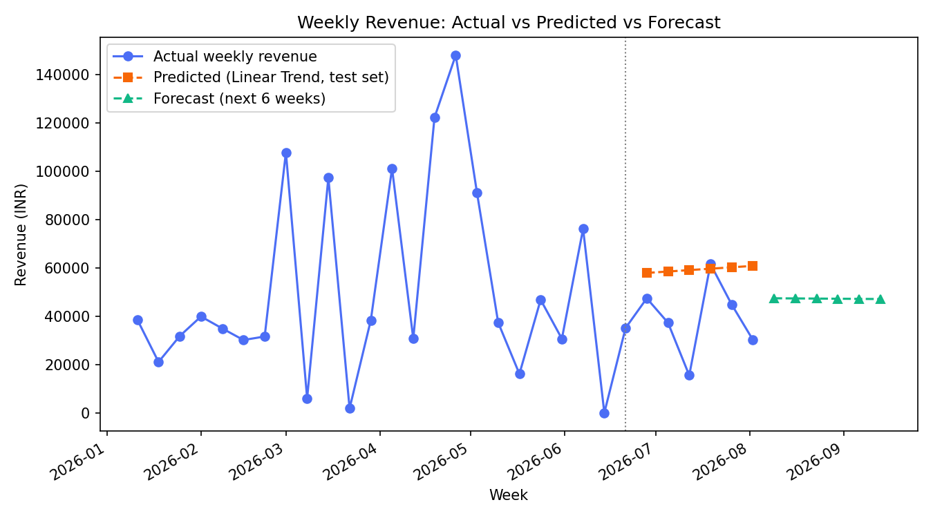
Blue: actual weekly revenue. Orange: model predictions on the 6 held-out test weeks. Green: forward forecast for the next 6 weeks. The dotted line marks the train/test split.

6.2 Transaction-level Regression — Actual vs Predicted
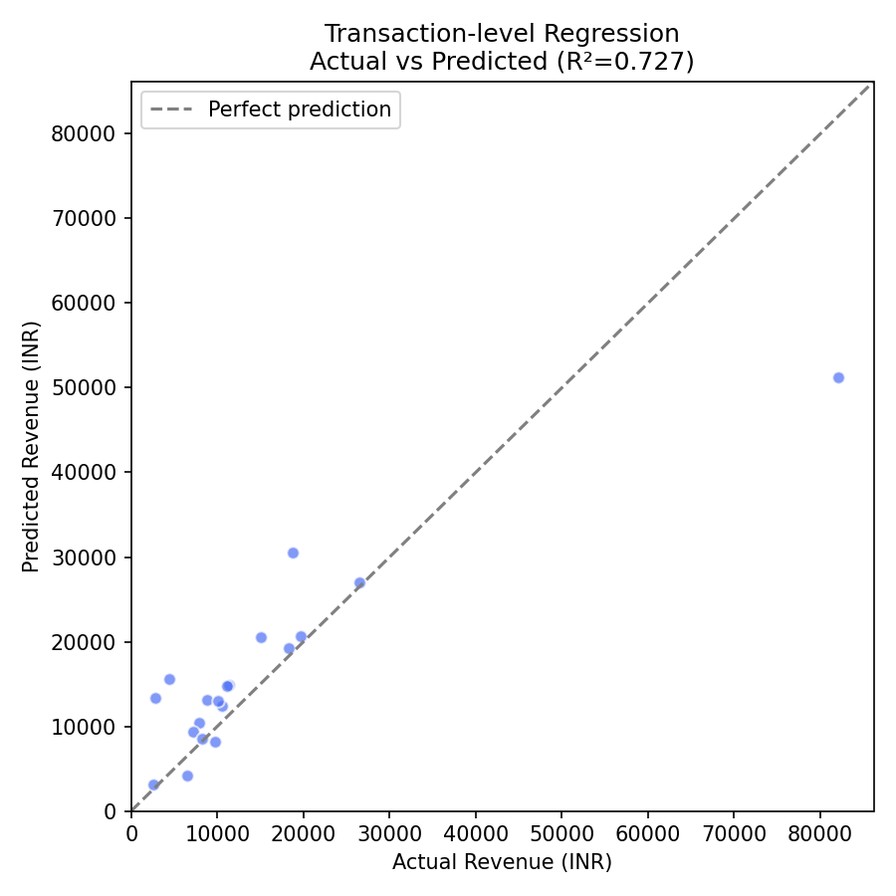
Each point is one held-out transaction. Points closer to the diagonal line are more accurate. R² = 0.727.

6.3 Model Comparison
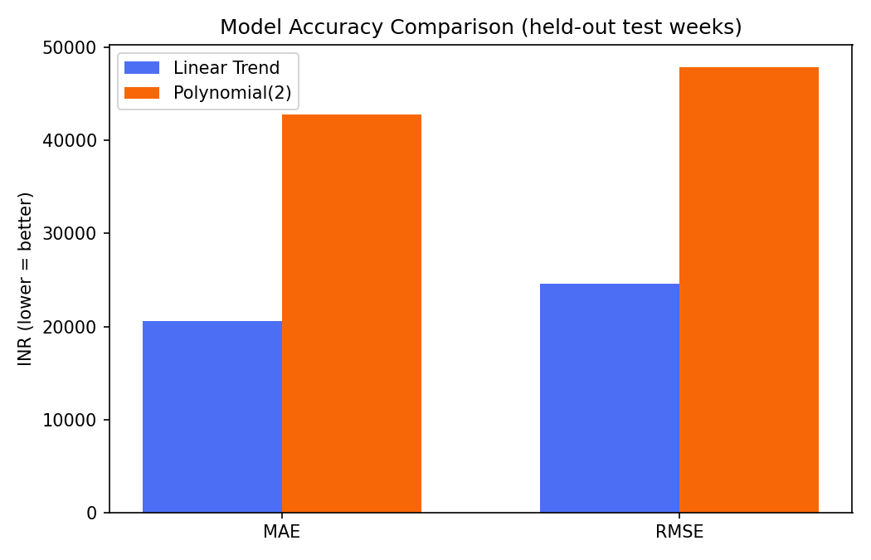
Lower MAE/RMSE is better. The Linear Trend model outperforms the Polynomial model on held-out weeks.

6.4 Monthly Revenue by Category
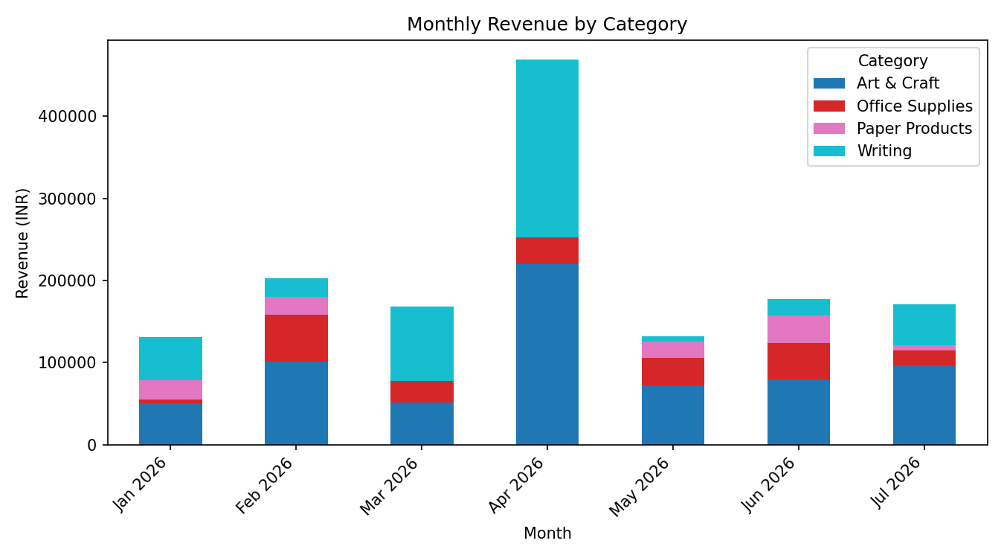
Revenue composition by category each month. April 2026 was the strongest month overall, driven largely by Art & Craft.

6.5 Residuals — Weekly Trend Model
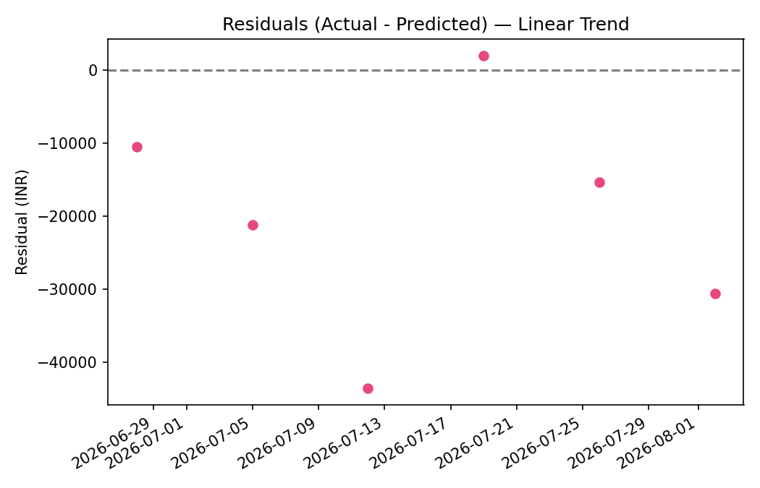
Actual minus predicted revenue for each held-out week. Residuals scattered without a clear pattern would indicate a well-specified model; here the spread is wide, consistent with the weak R² above.

7. Key Takeaways
- Total revenue across the dataset: ₹14,51,643 from 10,334 units sold over 100 orders.
- Order-level revenue is highly predictable from order attributes (R² ≈ 0.73) — useful for quoting or budgeting individual orders.
- Week-level revenue forecasting is unreliable with the current 100-row sample — more historical data and/or monthly (rather than weekly) aggregation is recommended before using the trend forecast for planning.
- April 2026 stands out as the peak revenue month, led by the Art & Craft category.

8. Files Delivered
- analysis.py — full Python pipeline: cleaning, both models, evaluation, and chart generation (reproducible end-to-end).
- weekly_revenue.csv — cleaned weekly revenue time series used for modeling.
- forecast.csv — 6-week forward revenue forecast.
- This report (Predictive_Analytics_Report.docx).

